On behalf of the Brazoria County Sheriff’s Office, you are hereby cordially invited to attend:

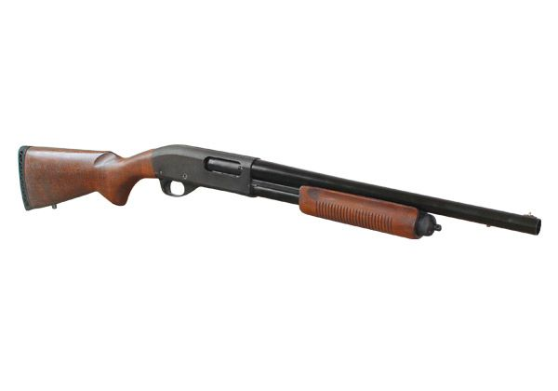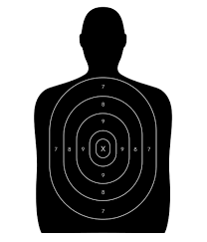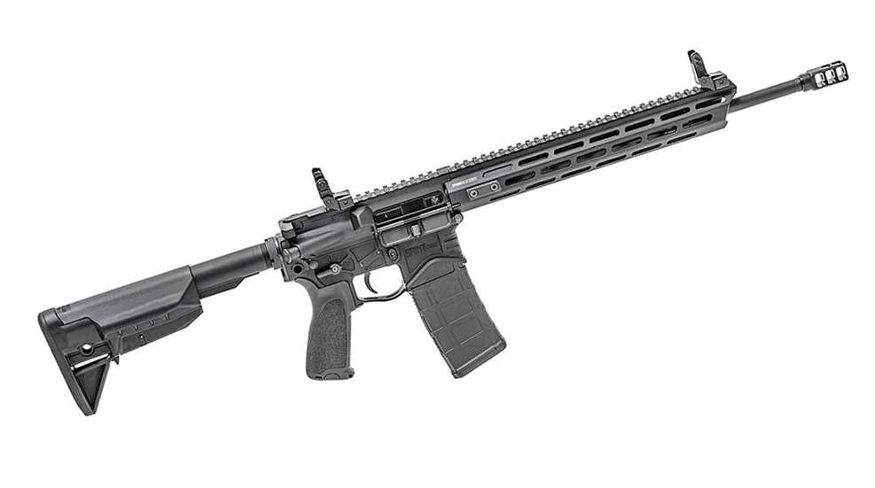

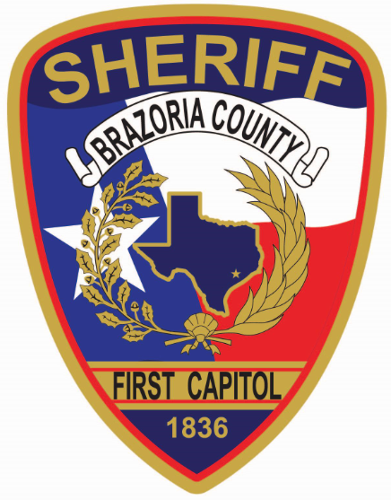

Patrol Rifle (Rifle & Shotgun)

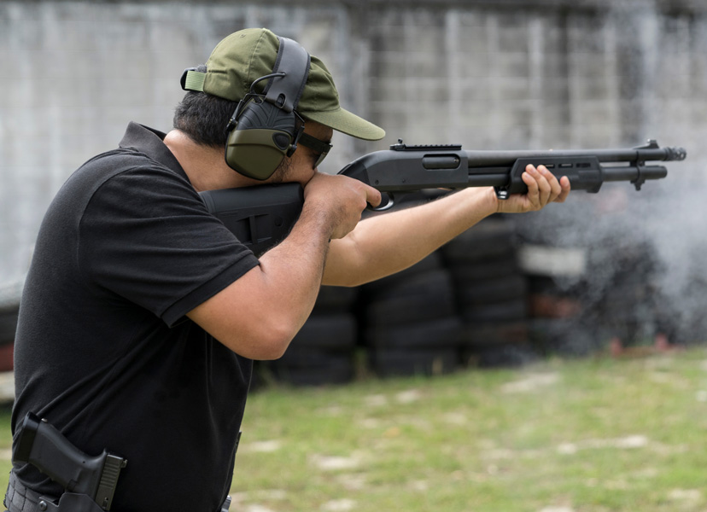

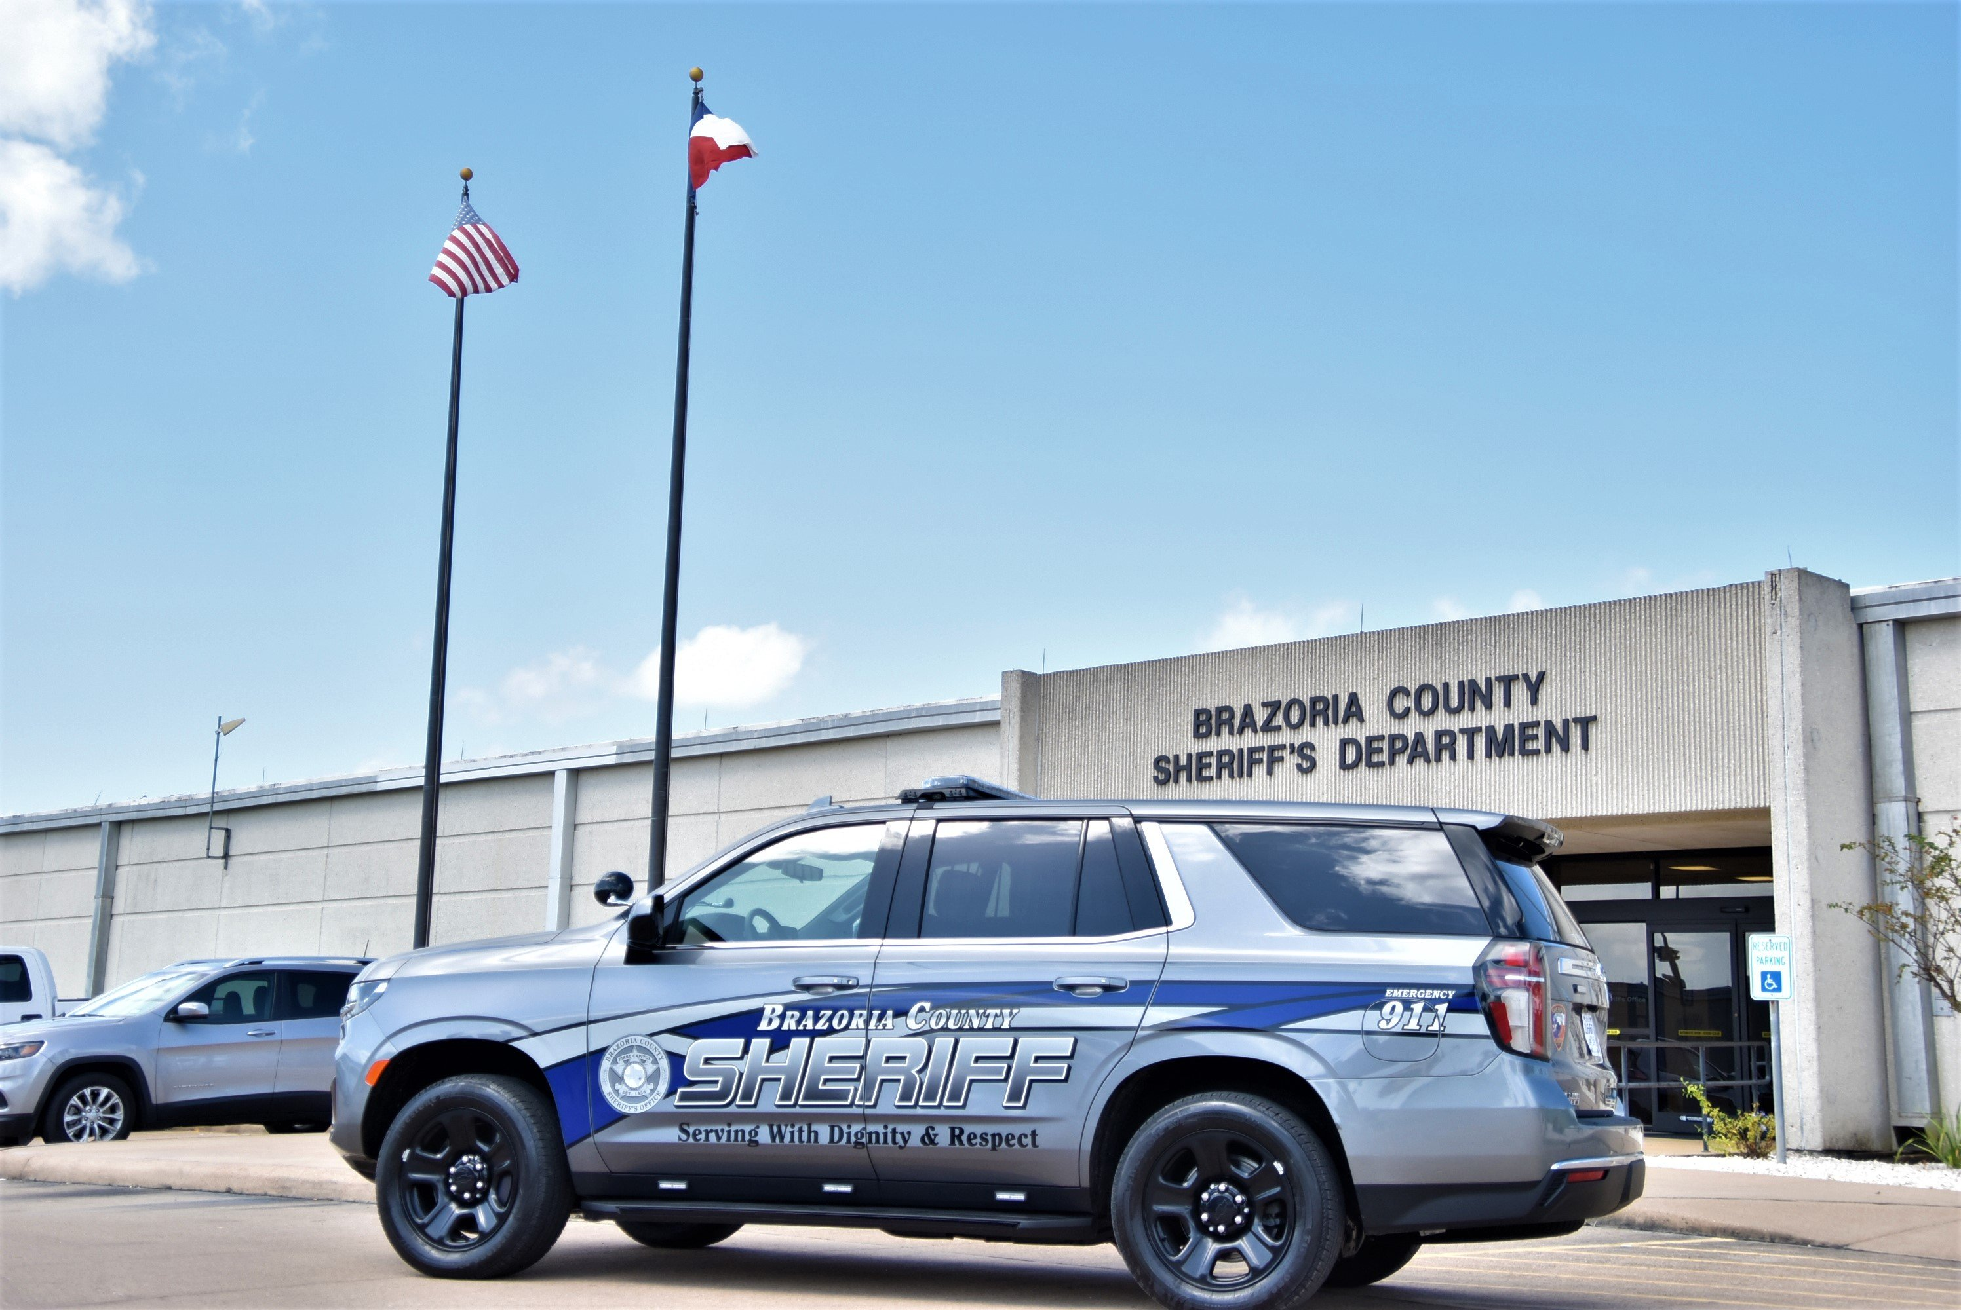

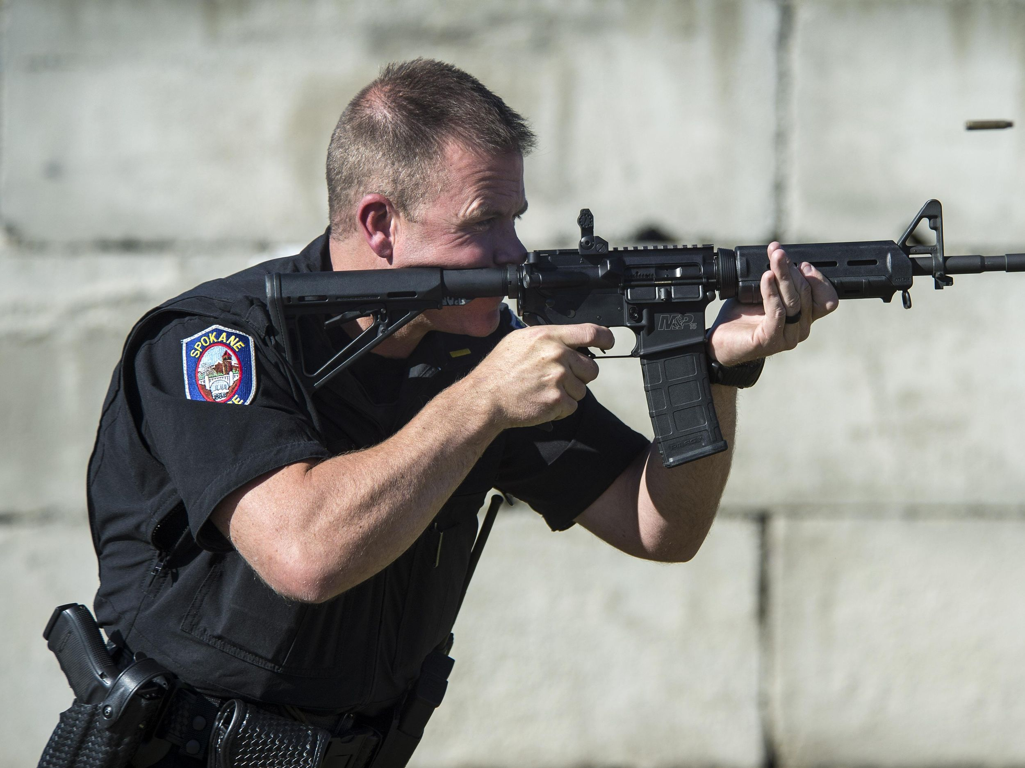

Course Name: Location:

TCOLE Course #: Brazoria County Sheriff’s Office

Date: 3602 County Road 45

Time: Angleton, TX 77515

Training Room #

Instruction provided by:

3322

Wednesday, April 12, 2023

8:00 a.m. to 5:00 p.m.

Gun Range

Sgt Isaac Riden

To register, click on the link below and submit the form to the Training Division.

[Course Pre-Registration Form](https://www.brazoriacountytx.gov/home/showpublisheddocument/14841/638016780650700000)

Questions?

Contact: Sgt Isaac Riden (979-864-2344), Sgt Sean Hodder (979-864-2066) or Sgt Chad Polinske (979-864-2224)

[IsaacR@brazoriacountytx.gov](mailto:IsaacR@brazoriacountytx.gov) [SeanH@brazoriacountytx.gov](mailto:SeanH@brazoriacountytx.gov) [ChadP@brazoriacountytx.gov](mailto:ChadP@brazoriacountytx.gov)